**Building SRAM With Transistor Logic**

By Elias Harju

**Project Objective**

In this project, I am building a RAM module using only transistors and breadboards to learn about the differences between DRAM and SRAM as well as logic gates, boolean algebra, and Karnaugh maps. DRAM and SRAM are two different types of computer memory and are used to store information that the computer is currently using. DRAM uses only 1 transistor and 1 capacitor to store memory, but it requires a more complex controller to constantly refresh the capacitors so that they do not lose the information they’re storing. SRAM does not require any capacitors or complex controllers, however, it does cost more to make because it needs more transistors than the DRAM.

**Existing Examples**

[RAM module build - part 1](https://www.youtube.com/watch?v=uYXwCBo40iA)

The above video is part of a series where the creator is trying to build an 8-bit computer. In this video, he builds the main piece of the RAM module which is very similar to my own project. This video is well done because it explains all of the different parts that are being used and each wire and chip is arranged step-by-step. It’s similar to my project because we are both building SRAM, but it is different because in the video they use microcontrollers which are much more compact than using only transistors.

**Relevant Vocabulary**

* Cache; an auxiliary memory from which high-speed retrieval is possible.
* Diode; a semiconductor that only allows current to flow in one direction.
* Flip-Flop; a type of circuit that can store and recall a single bit of information.
* Logic Gate; a device that performs a Boolean function.
  + NOT Gate; a NOT gate simply inverts a signal. There are NOT versions of every gate.
  + AND Gate; an AND gate requires all of its inputs to be powered to allow a signal to pass through.
  + OR Gate; an OR gate only needs one of its inputs to be powered to allow a signal to pass through.
  + XOR Gate; an XOR gate will let a signal through if only one of its inputs are powered.
* RAM; random access memory.
  + DRAM; dynamic RAM.
  + SRAM; static RAM.
* Semiconductor; a substance that has less conductivity than a conductor but more than an insulator.
* Transistor; a semiconductor with three connections.

**Relevant Concepts**

Boolean Algebra

Boolean algebra is different from standard algebra because rather than using numbers, the only values are ‘true’ and ‘false’, typically denoted as 1 and 0 respectively. Boolean algebra is used in computer science and engineering because components can only be in two states; powered or not powered. This is helpful because it means that you can test a circuit that you might be planning on building before it’s actually built. All you need to know is the different logic gates that the circuit will be composed from. This is because boolean functions and logic gates are different ways of representing the same thing. This is relevant to my project because it means I can see if my plan will work by first creating a boolean equation and then, if it works, going through the hassle of wiring it all together. 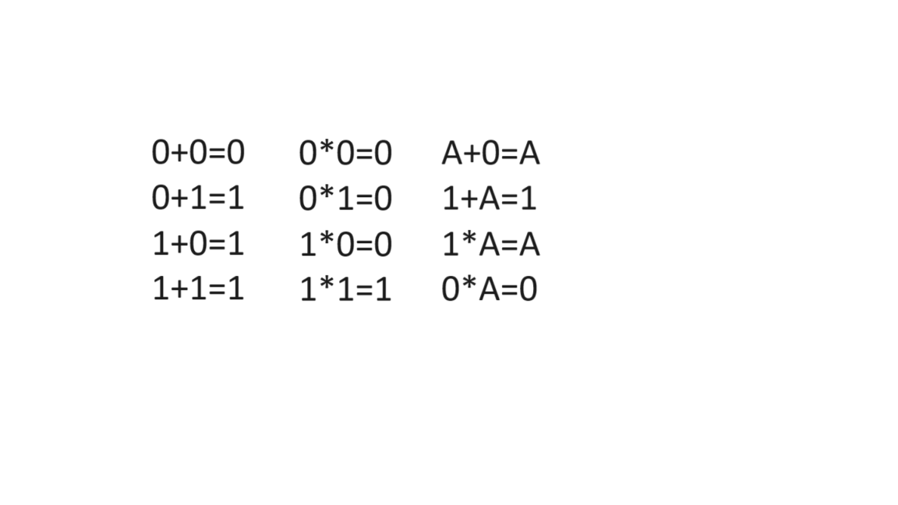

Logic Gates

In computers, logic gates are the building blocks of basically everything. They are small microcontrollers that allow for the computer to make simple yes or no decisions. They can translate boolean functions/expressions into a real movement or signal. When enough of these gates are put in sequence, they can imitate real decision making based on set parameters. These gates are built from transistors, resistors, and diodes wired together in specific sequence. For the purposes of my project, I decided to use transistors because they are already similar to the logic gates I’m trying to build. There are also versions of logic gates, however, that use only diodes and resistors, this works because of a diode’s property of only allowing current to flow one way. Resistors on their own are unable to form logic gates, so they are instead used in conjunction with transistors and diodes.

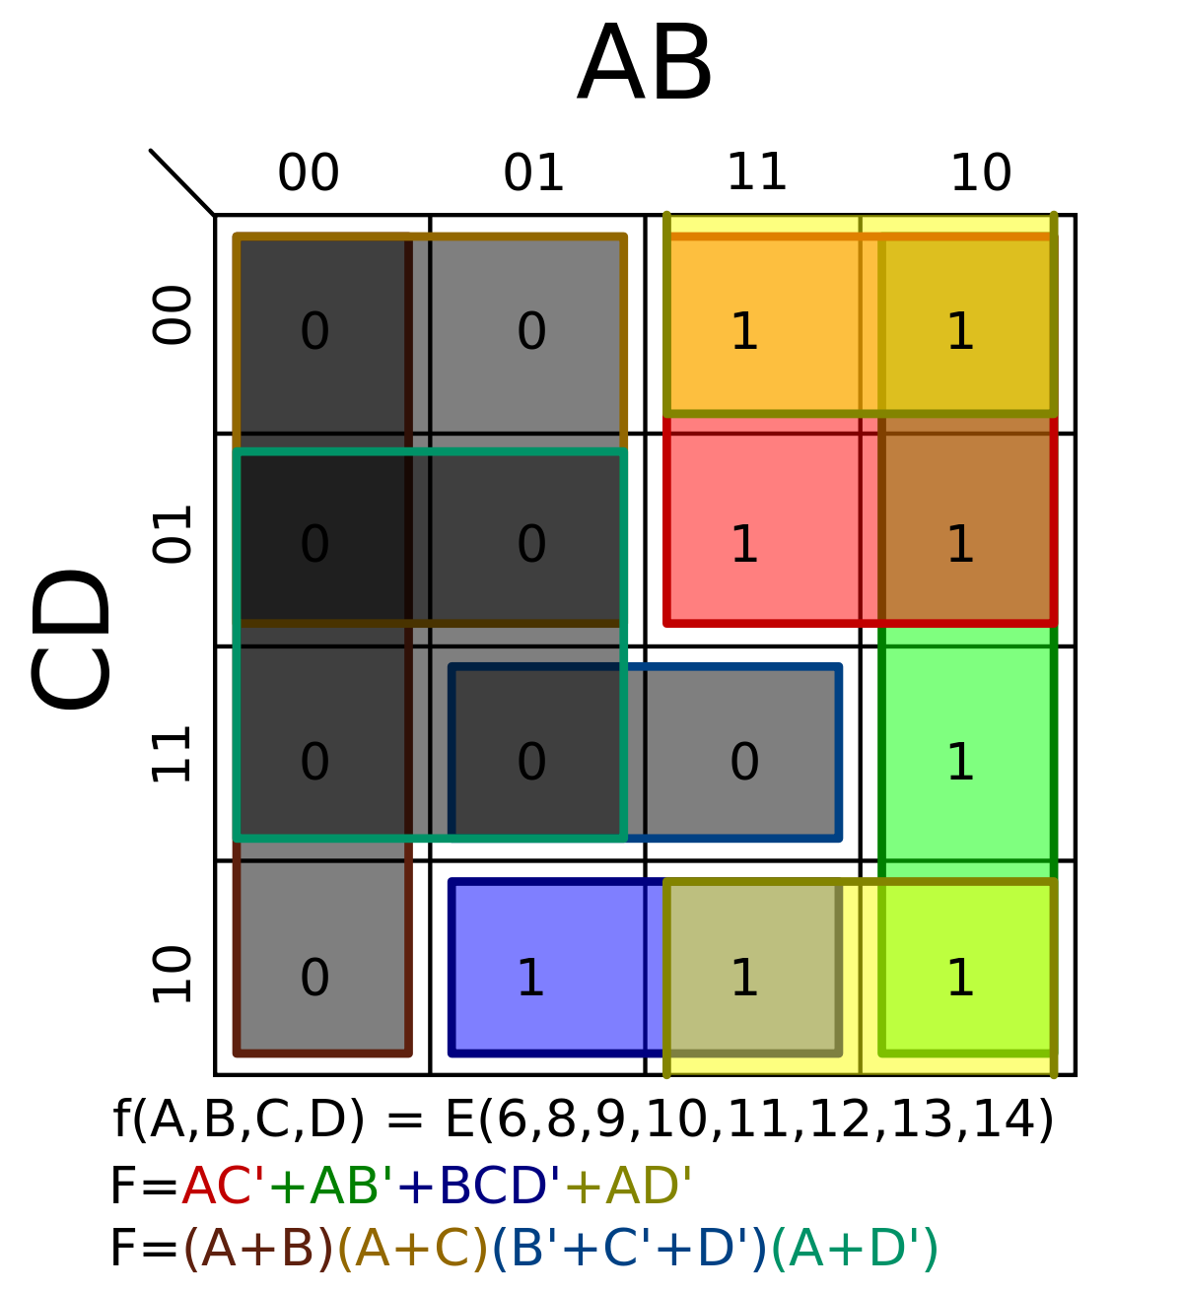

Karnaugh Maps

Karnaugh maps are related to boolean algebra because they are used to connect boolean equations to circuits or vice versa. Karnaugh maps, also known as K-maps are grids that are filled out with either 1s or 0s depending on where it is on the map and the different logic gates/rules in the circuit (shown on the right). The equation at the bottom of the image is derived from the K-map above it by comparing what squares are 1s or 0s to the inputs for its row. For example, if all the squares in the 00 row for AB of a K-map are 0, that means that if both A and B are 0, the final output will also be 0.

Transistor Logic

Transistor logic is simple, because it’s just about recreating all of the hypothetical logic gates with real ones made up of real electronics. The two main types of transistors are NPN and PNP transistors. NPN transistors become powered when enough positive current is transferred from the base pin to the emitter. PNP transistors, however, require enough negative current to be transferred from the emitter to the base. A transistor is essentially a gateway that is either opened or closed depending on whether or not its second input is being powered. Transistors can then be linked together so that they can do more logical operations and they become logic gates.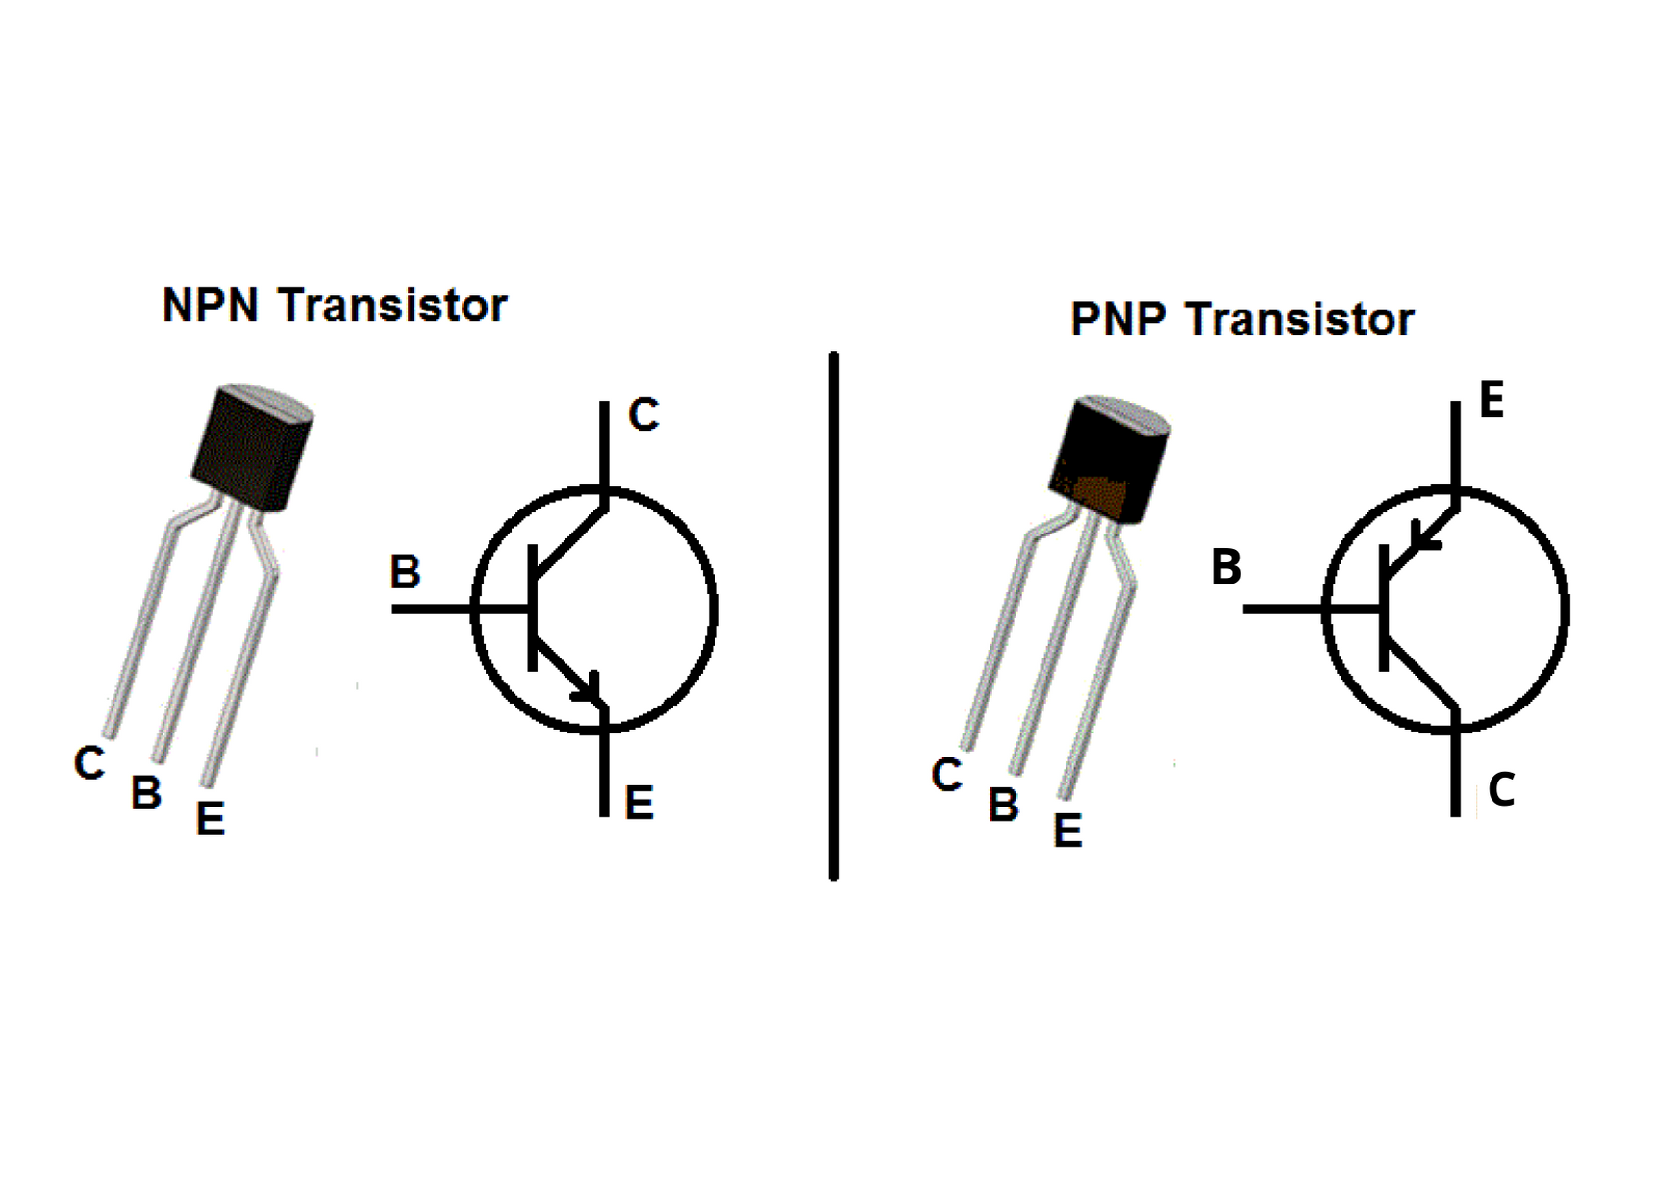

**APA References**

*Flip Flop types, truth table, circuit, working, applications*. Electronics For You. (2023, August 23). https://www.electronicsforu.com/technology-trends/learn-electronics/flip-flop-rs-jk-t-d#:~:text=A%20flip%2Dflop%20is%20a%20type%20of%20circuit%20that%20can,can%20store%20data%20over%20time.

Wikimedia Foundation. (2023, December 13). *Logic gate*. Wikipedia. https://en.wikipedia.org/wiki/Logic_gate

Eater, B. (2016, August 8). *Ram Module Build - Part 1*. YouTube. https://www.youtube.com/watch?v=uYXwCBo40iA

Wikimedia Foundation. (2023, December 18). *Karnaugh map*. Wikipedia. https://en.wikipedia.org/wiki/Karnaugh_map

*What is the difference between PNP and NPN?*. ShopTransmitter. (2018, August 13). https://shoptransmitter.com/blog/what-is-the-difference-between-pnp-and-npn/